Chapter 0 (User Registration)

**1. Create a project with JSON file**

Step 1- create a folder on your pc and open it using VS Code or Code editor

Step 2- Go to Vs code terminal manu and select New terminal option

Step 3 – use ‘npm init’ command for initialization the project .Gave the project name authour name all thouse thing and then save the project using ‘y’. After that create JSON file show on vs code .

2. **Install node module**

**After the project create we install the node module with help of npm (Node Package Manager)**

**For instal go to tarminal and use npm Install <pacakege name> or use npm i<package name>**

3. Create usercontraller.js file

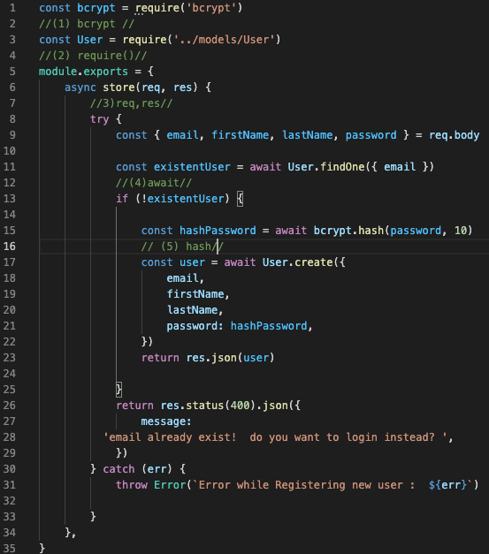

Define usercontroler..js

1.bcrypt:- bcrypt is a node package that use for build a password security that scales with a computation power . For install bcrypt we use npm install bcrypt.

2. requre :- requre is a spacel type of function that built in for load modules for different programming languages.

3. req(request)/res(response):- req is an object connecting http request that raised the event and res is atype of response that send back the desier http response.

4.Await:- await is a type of promises that used by operator. It can used by ‘async’ function within the js code or own js modules.

5.hash :- hash is a type of function that use for arbitory size data input and produces an out of fixed size data

6. create :- create is a method that use for construct a user model that used in database.

**4. Create User.js file**

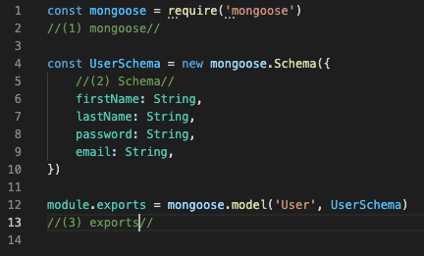

1. constract mongoose using requre function.

2 mongoose:- mongoose is a node package that use for object data modeling library for mongo DB database . Its managed the relationship between data and provides schema validtion . It also use for translate the object data between mongoDB and user .

3. Schema :- Schema is a data blueprint that collection of information that available on our environment.

4. exports:- The **module exports** in Node.js is used to export any literal, function or object as a module. It is used to include JavaScript file into node.js applications. The **module** is similar to variable that is used to represent the current module and **exports** is an object that is exposed as a module.

**5.Create Server.js File**

1.express:- Express.js is a web application framework for Node.js. It provides various features that make web application development fast and easy which otherwise takes more time using only Node.js. Express.js is based on the Node.js middleware module called **connect** which in turn uses **http** module. So, any middleware which is based on connect will also work with Express.js.

2.CORS:- cors is a node. js package for providing a Connect/Express middleware that can be used to enable CORS with various options.

3. .env :- .env is a costomize working enviroment variable and it is a hidden file .and it also use to connect the database .

4. Config:- config use for configure our application for using hard coded value or a JSON objects. That embladed iside an html or XML document.

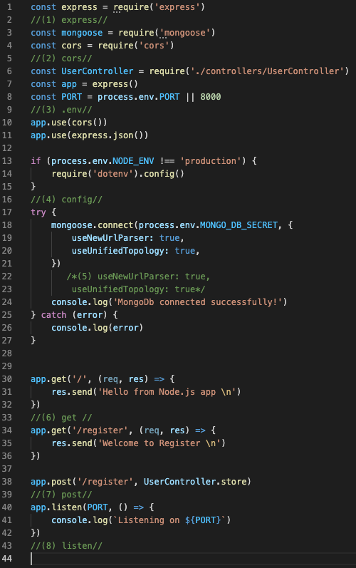

5.useNewUrlParser:true – this is added to allow user to fall back the old parser and find out the bug in a new perser.

useUnifiedTopology:true- it is use for true mongoDB driver is a new connection management engine.

6. Get :- it is used for running a spacific element among all the element which r present.

7.Post:- post is an http request that use for submit the achynchronous request from the server without reloading the pages.

8. lesten :- it is used for listen the request for the spacific host or port.

**6. Create.env file that consist of MONGO_DB connection**

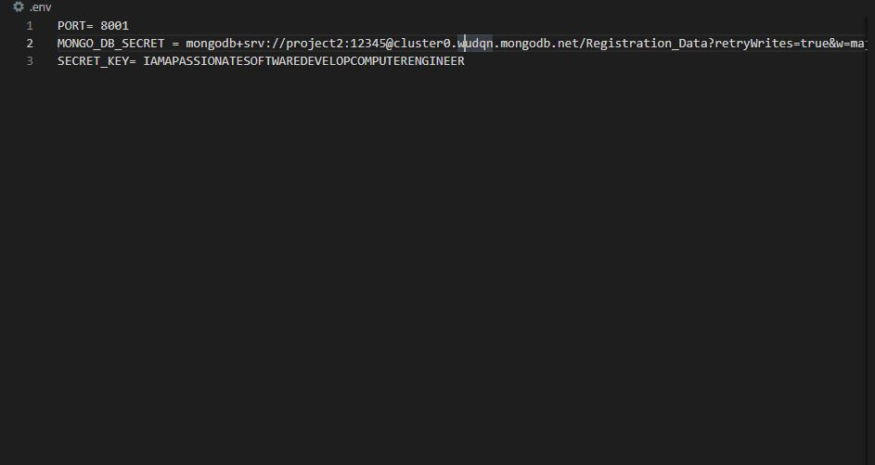

7. **Run the project**

After completing the js file code we run the project using npm

Go to terminal and use npm start for start the server, Or other we are use NODEMON package for start the server

**For Nodemon**

For nodemon install using npm i< nodemon>

Then configer the JSON file nodemon : start <start point>

Go to consol and npm start

**Configuration for nodemon in JSON**

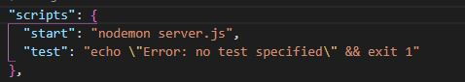

After connection is sussfully it show the result

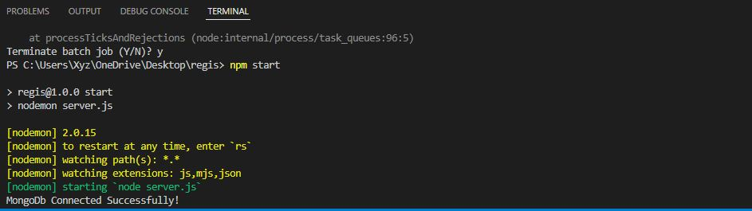

**8.Use method of request using postman and insomnia**

**8.1GET Method**

GET is used to request data from a specified resource.

Note that the query string (name/value pairs) is sent in the URL of a GET request:

/test/demo_form.php?name1=value1&name2=value2

**8.2 POST Method**

POST is used to send data to a server to create/update a resource.

The data sent to the server with POST is stored in the request body of the HTTP request:

POST /test/demo_form.php HTTP/1.1  
Host: tims03.com  
  
name1=value1&name2=value2

**8.3 PUT Method**

PUT is used to send data to a server to create/update a resource.

The difference between POST and PUT is that PUT requests are idempotent. That is, calling the same PUT request multiple times will always produce the same result. In contrast, calling a POST request repeatedly have side effects of creating the same resource multiple times.

**8.4 PATCH Method**

The PATCH method is used to apply partial modifications to a resource.

**8.5 DELETE Method**

The DELETE method deletes the specified resource.

**8.5 POSTMAN**

It is a software testing tool to test APIs. With this we can create, test, share and document APIs. It is a simple Graphic User Interface for sending and viewing HTTP requests and responses. It is used for backend testing where we enter the end-point URL, it sends the request for the server and receives the response back from server.

**How we use POSTMAN**

Step 1:- Go to the collection tab click on the ‘+’ button create a new collection it will appear name or other setting.

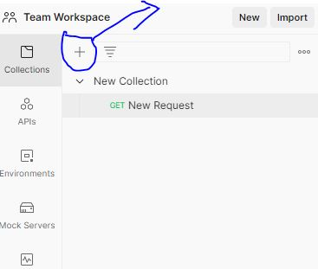

Step 2:- then select create a new request and it will open a window on post man application like this.

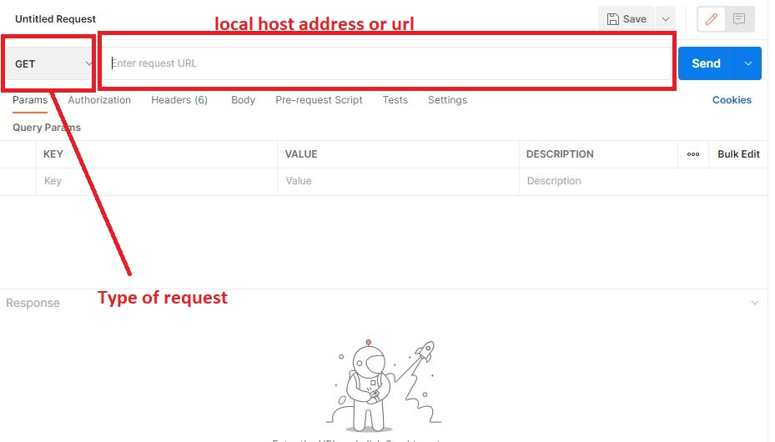

Step 3 :- set the address of your local host and add the request type get and chack the result. If it show 200 in green then it is ok.

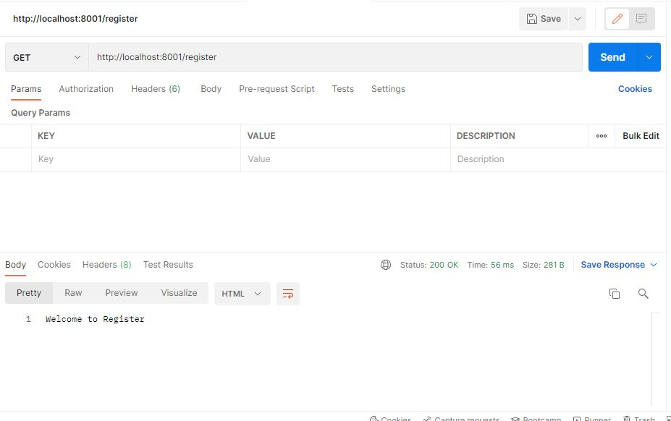

Step 4 - Set post request and put the value and check the status if it show 200 then it’s ok or if show 404 then error is process.

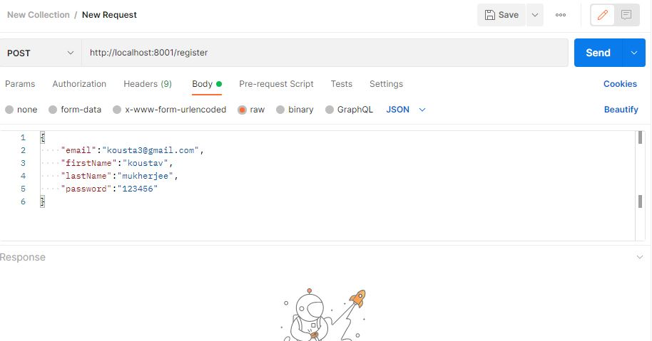

**INSOMNIA**

It is a free cross-platform desktop application that takes the pain out of interacting with and designing HTTP-based APIs. It combines an easy-to-use interface with advanced functionality like authentication helpers, code generation, and environment variables.